UTC Project Information – Project 2.11
Project Title | Culvert Rehabilitation using 3D Printed Diffusers
University | University of Maine
Principal Investigator | Roberto Lopez-Anido
PI Contact Information | rla@maine.edu
Co-PI(s) | Sunil Bhandari
Co-PI Contact Information | sunil.bhandari@maine.edu
Funding Source(s) and Amounts Provided | UMaine (Phases I and II + Phase III) : $158,467+ $142,566  MaineDOT(Phase I): $6,500  NHDOT (Phase III) : $20,000
Total Project Cost | $327,533
Agency ID or Contract No | 69A3551847101
Start and End Dates | 07-01-2020 to 06-30-2022
Brief Description of Research Project | What are culvert diffusers and why are they used?  - Culverts are installed in highways to control water flows  - Culverts deteriorate with age and need repairs.  Current culvert retrofit technology:  - Use slip-liners  - Problem: reduction of the cross-section and hence the capacity of the culvert.  New culvert outlet diffusers technology:  - Increase the culvert capacity and compensate for the losses due to liner retrofit  - Reduce outlet flow velocity and minimize erosion.  Project objectives:  - Explore the feasibility of using large scale 3D printing to manufacture culvert outlet diffusers with site-specific optimized designs.  - Design and manufacture an experimental 3D printed culvert diffuser prototype to evaluate hydraulic capacity at the site  - Assess the use of bio-based renewable polymer composites for manufacturing culvert diffusers.  - Explore segmental manufacturing of 3D printed culvert diffusers.  - Evaluate the performance of 3D printed culvert diffuser in the field.
Describe Implementation of Research Outcomes (or why not implemented) | 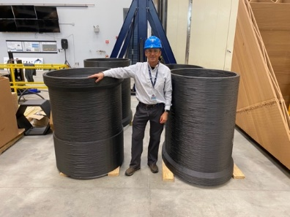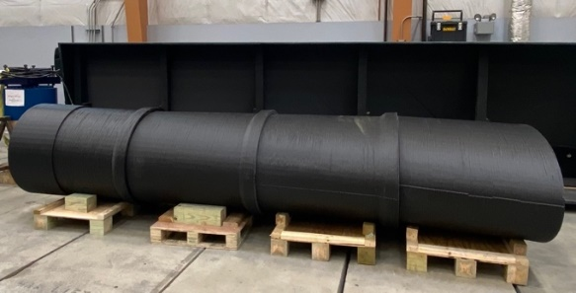  3D printed culvert outlet diffuser segments. Assembled culvert diffuser segments
Impacts/Benefits of Implementation (actual, not anticipated) | - Design of the diffuser is unique depending on the culvert and the site conditions.  - Significant cost reduction to current manufacturing methods.  - 3D printing is more cost effective for larger parts.  - Segmental manufacturing of long and narrow parts enables faster manufacturing times.  - Optimized designs of culvert diffusers based on site-specific hydraulic conditions can be manufactured using large-scale 3D printing at lower cost than current methods.  - Hydraulic performance evaluation in the field, as well as ease of installation and durability have to be demonstrated for technology transfer.
Web Links  - Reports  - Project website | Bhandari, S., Lopez-Anido, R.A., Anderson, J. and Mann, A. “Large-scale extrusion-based 3D printing for highway culvert rehabilitation,” ANTEC 2021, Society of Plastic Engineers, Hybrid Edition, Mar. 22-23, 2021.

