UTC Project Information – Project # 2-4
Project Title | Thermoplastic Composites by 3D Printing and Automated Manufacturing to Extend the Life of Transportation Facilities
University | University of Maine
Principal Investigator | Roberto Lopez-Anido
PI Contact Information | rla@maine.edu
Co-PI(s) | Sunil Bhandari
Co-PI Contact Informat. | sunil.bhandari@maine.edu
Funding Source(s) and Amounts Provided | DOT (Phase 1 + Phase 2 + Phase 3): $52,881 + $51,522 + $192,171  UMaine (Phase 1 + Phase 2 + Phase 3): $97,031 + $106,945 + $92,523
Total Project Cost | Phase 1 + Phase 2 + Phase 3: $149,912 + $158,467 + $284,694
Agency ID/ Contract No. | 69A3551847101
Start and End Dates | 01-01-2019 and 12-31-2022
Brief Description of Research Project | This project aims to extend the life of transportation facilities by using 3D printed molds to manufacture thermoplastic composite molds that can be used as formwork for precast concrete. This project addresses the need to develop durable and cost-effective forms and tooling for precast concrete parts used in transportation.  The research evaluates the mechanical performance of the 3D printed formwork after repeated use during casting of concrete, and removal of cured concrete parts. Additionally, the research assesses the durability and dimensional tolerance of bio-based 3D printed forms.
Describe Implementation of Research Outcomes (or why not implemented) | 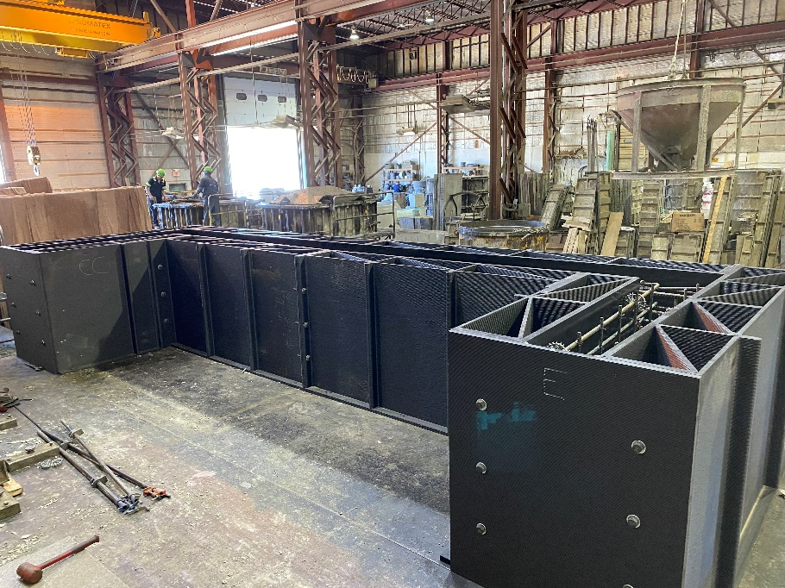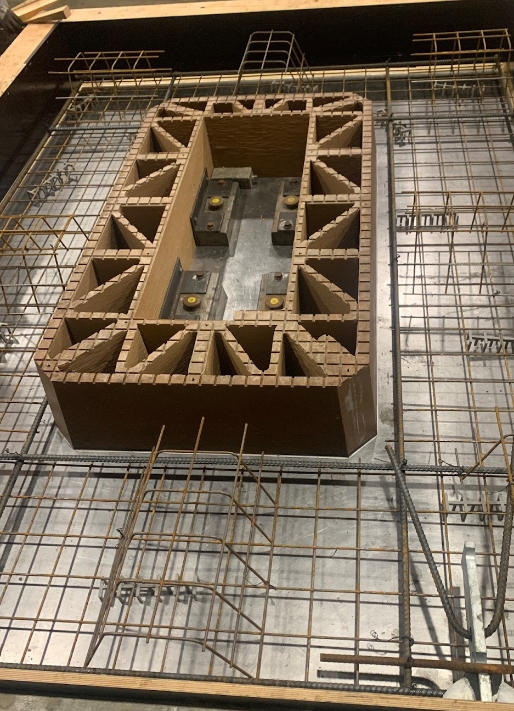  Large-scale railroad bridge ballast retainer formwork at American Concrete Ind. plant in Veazie, Maine. 3D printed form of at the Unistress Corp. precast concrete plant in Pittsfield, MA.
Impacts/Benefits of Implementation (actual, not anticipated) | a. DOTs will be able to specify durable and cost-effective thermoplastic composites with optimized designs using large-scale 3D printings for precast concrete forms and tooling.  b. Optimized 3D printed forms will increase the longevity of precast concrete elements and parts.
Web Links  - Reports  - Project website | Lopez-Anido, R., Davids, W., Bhandari S., Sheltra C.A., Erb, D. F., and Abdel-Magid, B., “Overview of thermoplastic composites in bridge applications,” Structural Faults + Repair-2022 and European Bridge Conference-2022, 13 pp., June 20-23, Edinburgh, Scotland. https://www.structuralfaultsandrepair.com/  Bhandari, S., A graph-based algorithm for slicing unstructured mesh files, Additive Manufacturing Letters, Vol. 3, Dec. 2022, 100056 (Open Access) https://doi.org/10.1016/j.addlet.2022.100056  Bhandari, S., Lopez-Anido, R.A., Saavedra Rojas, F., and LeBihan, A. “Design and Manufacture of Precast Concrete Formwork Using Polymer Extrusion-Based Large Scale Additive Manufacturing and Postprocessing,” STP1644 on ASTM International Conference on Additive Manufacturing (ICAM 2021).  Bhandari, S., Lopez-Anido, R., and Anderson, J. “Large scale 3D printed thermoplastic composite forms for precast concrete structures,” 5th International Conference & Exhibition on Thermoplastic Composites, ITHEC 2020 Virtual Edition, in proceedings p.182, Oct. 13-15, Bremen, Germany (2020). Video  Bhandari S., and Lopez-Anido, R.A. “Discrete event simulation thermal model for extrusion-based additive manufacturing of PLA and ABS,” Materials, 13(21), 4985 (2020) https://doi.org/10.3390/ma13214985 (Open Access).  Bhandari S., Lopez-Anido R.A. and Gardner, D.J. “Enhancing the interlayer tensile strength of 3D printed short carbon fiber reinforced PETG and PLA composites via annealing,” Additive Manufacturing 30, 1000922 (2019). https://doi.org/10.1016/j.addma.2019.100922

